

**INTERNATIONAL PROGRAMMERS TRAINING CENTER**

**SOFTECH APTECH**

**---- ----**

**PROJECT: BEAUTY CARE**

**Lecturer:** Mr Nguyen Ho Long Hai

**Group Name:** 1

**Batch:** 146

**Semester:** 1

**Members:**

1. Ngo Thien An

2. Nguyen Dinh Minh Duc

3. Vo Van Duc

4. Nguyen Thanh Kien

5. Doan Thanh Nhan

**DANANG, VIETNAM   
SEP 2018**

|  |
| --- |
| **SOFTECH APTECH** |
| **EProject Document** |
| **BEAUTY CARE** |
|  |
| |  |  | | --- | --- | | Group Name: Group 1 | | | Group members | 1. 1. Ngo Thien An 2. 2. Nguyen Dinh Minh Duc 3. 3. Vo Van Duc 4. 4. Nguyen Thanh Kien 5. 5. Doan Thanh Nhan | | Instructor | Mr.Nguyen Ho Long Hai | | Batch | 146 | | Semester | 1 | |
|  |

**Danang, Vietnam, 09/2018**

**TEACHER’S EVALUATION**

……………………………………………………………………………………………………………………………………………………………………………………………………………………………………………………………………………………………………………………………………………………………………………………………………………………………………………………………………………………………………………………………………………………………………………………………………………………………………………………………………………………………………………………………………………………………………………………………………………………………………………………………………………………………………………………………………………………………………………………………………………………………………

………………………………………………………………………………………………………………………………………………………………………………………………………………………………………………………………………………………………………………………………………………………………………………………………………………………………………………………………………………………………………………………………………………………………………………………………………………………………………………………………………………………………………………………………………………………………………………………………………………………………………………………………………………………………………………………………………………………………………………………………………………………………………………………………………………………………

……………………………………………………………………………………………………………………………………………………………………………………………………………………………………………………………………………………………………………………………………………………………………………………………………………………………………………………………………

Table of Contents

ACKNOWLEDGEMENTS 6

ABSTRACT 7

LIST OF FIGURES 8

CHAPTER 1: INTRODUCTION 9

1.1 HTLM5: 9

1.2 CSS- CSS3: 10

1.3. BOOSTRAP 3: 12

1.4. ANGULARJS: 14

CHAPTER 2: PROBLEM DEFINITION 19

2.1. The Home Page should be created making use of Frames with a suitable logo: 19

2.2. The look and feel of the project must be made user friendly and uniformity in the color combination must be maintained: 19

2.3. About us, Contact Us (address and map) must be added. In the Contact Us page the website of all the shops location must be given: 19

2.4. All the categories of the products like HAIR, SKIN, MAKE-UP KITS, NAIL PAINTS, NAIL ARTS, JEWELLRY, WEDDING KITS, UPCOMING PRODUCTS & so on. For each product the cost must be mentioned in the list: 19

2.5. Feedback page must be added to take the valuable feedback from the users: 19

2.6. Contact Us, About Us: 19

2.7. Use GeoLocation API to show the address or location of SIMPLON’s Beauty care center on the maps: 20

2.8. Gallery section can be included: 20

2.9. Navigation of the project must be made user friendly: 20

2.10. Customer must be allowed to place the order by selecting the product: 20

2.11. While placing the dummy order, the total cost of the order must be calculated: 20

CHAPTER 3: REQUIREMENT ATTRIBUTES 21

3.1. Main Requirements: 21

3.2. Critical Use Case Specification: 21

3.3. Use case Diagram: 25

CHAPTER 4: DESIGN PROTOTYPE 26

4.1. Home page prototype: 26

4.2. Products page prototype: 27

4.3. Product detail page prototype: 28

4.4. Contact us page prototype: 29

4.5. About us page prototype: 30

CHAPTER 5: TECHNICAL 31

5.1. Bootstrap framework: 31

5.2. AngularJS framework: 31

5.3. Node JS: 31

CHAPTER 6: THE PAGES BASIC OF WEBSITE: 32

6.1. Home page screenshot: 32

6.2. Products page screenshot: 33

6.3. Product detail page screenshot: 34

6.4. Checkout page screenshot: 35

6.5. Contact us page screenshot: 36

6.6. About us page screenshot: 37

CHAPTER 7: USER GUIDE 38

7.1. Instructrion: 38

7.2. Running step by step: 38

7.2.1. Download project: 38

7.2.1.1. Without GIT: 38

7.2.1.2. Using GIT: 38

7.2.2. Running server: 38

7.2.3. Running web pages: 39

# ACKNOWLEDGEMENTS

In the process of completing this project, we have received great deal of helps, guidance and encouragements from teachers and friends.

First of all, I would like to express my deepest thanks to my instructor**, Mr.Nguyen Ho Long Hai** who given me suggestions on how to shape the study and always been most willing and ready to give me valuable advice, helpful comments as well as correction my project.

Next, we would like to express my gratitude to all teachers as well as other parts of Softech Aptech centers have created the best conditions to help me complete this project.

# ABSTRACT

HTML5 is currently under development as the next major revision of the HTML standard. Like its immediate predecessors, HTML 5, HTML5 is a standard for structuring and presenting content on the World Wide Web. The new standard incorporates features like video playback and drag-and-drop that have been previously dependent on third-party browser plug-ins such as Adobe Flash, Microsoft Silverlight, and Google Gears.

The HTML5 specification was adopted as the starting point of the work of the new HTML working group of the World Wide Web Consortium (W3C) in 2007. According to the W3C timetable, it is estimated that HTML5 will reach W3C Recommendation by late 2010.

The HTML5 syntax is no longer based on SGML despite the similarity of its markup. HTML5 also incorporates *Web Storms 3.1*, another WHATWG specification.

In addition to specifying markup, HTML5 specifies scripting application programming interfaces (APIs). Existing document object model (DOM) interfaces are extended and de facto features documented. There are also new APIs, such as canvas element for immediate mode 2D drawing, timed media playback, offline storage database, document editing, drag-and-drop, cross-document messaging, browser history management, MIME type and protocol handler registration, Microdata, Geolocation etc.

**LIST OF FIGURES**

Figure 1.1: HTML5 Logo 9

Figure 1.2: CSS 3 Logo 10

Figure 1.3: Bootstrap 3 Logo 12

Figure 1.4: AngularJS Logo 14

Figure 1.5: MVC software Architecture Pattern 16

Figure 1.6: MVC Example in AngularJS 17

Figure 1.7: Relationships among Components 18

Figure 3.1: User use case diagram 25

Figure 4.1: Website mapping 26

Figure 4.2: Homepage prototype 27

Figure 4.3: Products page prototype 28

Figure 4.4: Product detail page prototype 30

Figure 4.5: Contact us page prototype 32

Figure 4.6: About us page prototype 34

Figure 5.1: Link bootstrap.min.js 35

Figure 5.2: Link Angular.js 35

Figure 5.3: Node JS version 36

Figure 6.1: Homepage 37

Figure 6.2: Products page 38

Figure 6.3: Product detail page screenshot 40

Figure 6.4: Checkout page screenshot 41

Figure 6.5: Contact us page screenshot 43

Figure 6.6: About us page screenshot 45

# CHAPTER 1: INTRODUCTION

## 1.1 HTLM5:



***Figure 1.1: HTML5 Logo***

The web is constantly evolving. New and innovative websites are being created every day, pushing the boundaries of HTML in every direction. HTML 4 has been around for nearly a decade now, and publishers seeking new techniques to provide enhanced functionality are being held back by the constraints of the language and browsers. To give authors more flexibility and interoperability, and enable more interactive and exciting websites and applications, HTML 5 introduces and enhances a wide range of features including form controls, APIs, multimedia, structure, and semantics.

Work on HTML 5, which commenced in 2004, is currently being carried out in a joint effort between the W3C HTML WG and the WHATWG. Many key players are participating in the W3C effort including representatives from the four major browser vendors: Apple, Mozilla, Opera, and Microsoft; and a range of other organisations and individuals with many diverse interests and expertise.

HTML5 is a specification for how the web's core language, HTML, should be formatted and utilized to deliver text, images, multimedia, web apps, search forms, and anything else you see in your browser. In some ways, it's mostly a core set of standards that only web developers really need to know. In other ways, it's a major revision to how the web is put together. Not every web site will use it, but those that do will have better support across modern desktop and mobile browsers (that is, everything except Internet Explorer).

History of HTML till now

• HTML 3.0 was developed in 1995

• HTML 3.2 was completed by 1997

• HTML 4 was developed in the year 1998

• In this year 1998 W3C stopped working on HTML and started working on XML based HTML that is XHTML. And it is known as XHTML 1.0.It has completed in the year 2000.

• In parallel with XHTML W3C worked on different language that is not compatible to HTML and XHTML 1.0, known as XHTML2.

• Introduction of Xforms , a new technology which is meant to be the next generation of web forms renewed interest in renovating HTML, rather than developing a brand new language for web.

• HTML5 was first started by Mozilla, Apple, and Opera under a group called the WHATWG (Web Hypertext Application Technology Working Group). In 2006 W3C showed an interest in HTML5 and in 2007 they created a working group to work in HTML5 project. HTML5 is still under development.

## 1.2 CSS- CSS3:



***Figure 1.2: CSS Logo***

CSS stands for Cascading Style Sheets, it is merely a text file with the name extension is .css. In this style sheet contains CSS commands. Each command of CSS will format a certain section of HTML such as: font of the text, borders, background color, align images etc ..

Previously when no CSS, web designers have to mix the ingredients and contents shown together. But with the advent of CSS, it is possible to completely separate the presentation and content. Help for the code of the website also more compact and more importantly is easy to edit more.

Before you begin to learn more about CSS I want you to know a little about its strength in web design. For example, if you work with HTML and you want the font of the entire site is Arial. You'll have to go to work like this for all the .html file that you have. But if you use CSS, you only need to do once, and all other pages will automatically be changed.

Three ways to format web pages:

There are three ways you can use to format the site are: local, embedded on the page and a link to a separate CSS file. In fact, the last way is to link to a separate file is used most commonly. But you should also know about the remaining two ways because sometimes you have to use it but not much.

1. Local - CSS code is inserted directly into the HTML tag:

Local formatting that you use CSS code directly into HTML tags and only have an impact on that card.

Example:

1 <p style=”font-size:16pt; font-weight:bold; color:blue;”>

2 If you add CSS code on the card it will change the way the browser displays

3 </p>

2. Dip the website:

The second way is that you declare CSS code within the tags <style> </ style> is placed in the <head> </ head> of the document. Basically it is only a local impact on the file you insert this CSS code. It has a larger sphere of influence is the local inserting been said above, but it does not affect other files in the same site.

Example:

1 <head>

2 <title> Embed in website</title>

3 <meta http-equiv=”Content-type” content=”text/html;charset=utf-8″ />

4 <style type=”text/css”>

5 h1 {font-size: 16px;}

6 p {color:blue;}

7 </style>

8 </head>

3. Link to a separate file:

This last fact a new way is the true power of CSS because you only need to create a CSS file and write the code only once. It will affect the entire site, not just affect a single .html file or just a card in the thousands of cards that you have. This way we can be completely separated from the composition and content presentation from each other. If you write the whole CSS code in a file and link it to the rest of the pages, then changing the repair site becomes extremely simple.

To link the CSS file to all your .html file, you just insert the following code between the <head> </ head> of the document:

Example:

<link href=”style_sheet.css” rel =”stylesheet” type=”text/css” />

And the browser will automatically use style_sheet.css files to the format for your website. Of course you wrote style_sheet.css file and CSS code.

The last thing you need to know about using CSS 3 is kind:

Local> Embedded Page> Link to a separate file

This formula means a Local "beat" from Embedded page and Link to a separate file. Or in other words, the local embedding is the most powerful, then to Embedded pages and eventually link to a separate file.

## 1.3. BOOSTRAP 3:

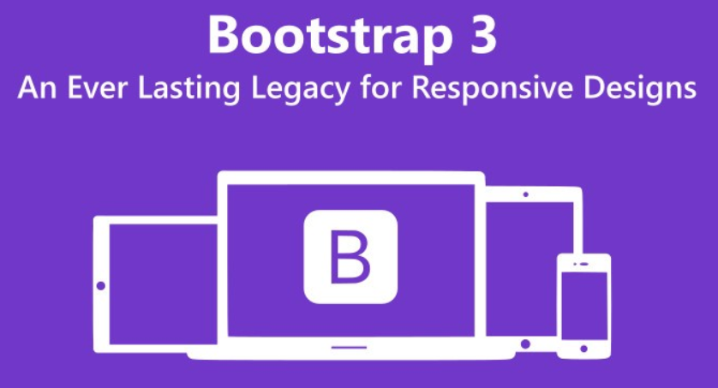

***Figure 1.3: Bootstrap 3 Logo***

**1.3.1. Introduction to Bootstrap:**

Bootstrap is an intuitive and open-source framework that makes front-end development of Web applications simpler as well as quicker. So, it is also known as the front-end framework. Primarily, Bootstrap aims to make responsive Web applications as well as Websites. In fact, it is presently the most popular CSS framework for building responsive Websites.

The framework encompasses JavaScript, CSS, and HTML for developing custom components while designing Webpages. Developed by the Twitter team, Bootstrap alo supports HTML5 and CSS3. It includes a free set of tools for creating Web applications and Websites.

Bootstrap consists of CSS and HTML based templates for designing a variety of components such as forms, layout, navigation, and even JavaScript extensions. It also includes a set of defined CSS classes that Web developers can use directly. The framework also uses JavaScript/jQuery framework for creating effects, styles, and actions for its components. In short, bootstrap is a CSS framework, a template system, and a JavaScript toolkit.

Web developers use CSS for applying styles to the elements of a Webpage by creating as well as assigning classes to these elements. However, Bootstrap automates this styling task by facilitating a developer to include the Boostrap files and state the predefined class names for the elements. This also eliminates the need of writing custom CSS classes for styling the elements. Thus, Bootstrap saves a lot of time while designing Webpages.

**1.3.2. Benefits of Bootstrap:**

There are many reasons why Web designers and developers prefer Bootstrap. Following are these reasons:

⇨ ***Easy and Flexible Enough to Get Started:*** Using Bootstrap is extremely easy, adaptable, and quick. Web developers can use it along with CSS, dynamic stylesheet language (Less), or Syntactically Awesome Style Sheets (Sass). Both Less and Sass are style sheet languages. While Less is compiled into CSS, Sass in interpreted into CSS. Further, there are different ways of adding Bootstrap to a Web project, which shows its flexibility.

⇨ ***100% Responsive Designs:*** A Website should be responsive to each Internet-enabled device. For example, it should adapt to the screen of a smartphone or tablet without compromising its smooth appearance and pleasant navigation. This is exactly what Bootstrap ensures through its fluid grid layout that readjusts itself dynamically to the screen resolution. The ready-made Bootstrap classes enable identifying the number of spots in the grid that each column should use. This helps in identifying points at which the columns should load horizontally rather than vertically for displaying the requested page accurately on the targeted smartphone. Bootstrap 3 comes with the mobile-first approach by offering mobile-first styles.

⇨ ***Great Grid System:*** Bootstrap implements a 12-column, responsive grid that supports offset and nested elements.

⇨ ***Better Development Speed:*** Rather than coding from scratch, Bootstrap allows using ready-made blocks of code for designing a Webpage. Merging these blocks with the code for cross-browser compatibility and CSS-Less functionality can save several hours of coding. Even for backend developers who need to do some user interface modifications, Bootstrap is efficient. This is because there is no need for them to know HTML and CSS well for using Bootstrap.

⇨ ***Browser Compatibility:*** Bootstrap resolves several cross-browser compatibility issues. This means a Web application made using Bootstrap runs smoothly in Chrome, Safari, Internet Explorer and Firefox.

⇨ ***Customization:*** It is possible to use Bootstrap as per the distinct design requirements. Web developers can select the required aspects by ticking off those that are not required. These aspects are available on the Bootstrap customize page, which includes common CSS, components, JavaScript components, and utilities. This is the custom version of Bootstrap, which is ready for download.

⇨ ***Consistency:*** Initially, a few Twitter team members expanded the framework for improving the consistency across the internal tools. However, later, Mark Otto who is the Co-founder released the first open-source Bootstrap version after comprehending the framework’s potential. He also depicted how the framework expanded through the single core concept of combining designers and developers.

⇨ ***Big Support:*** There is a big supportive community for Bootstrap due to which Web developers can obtain any kind of help at any time. Moreover, the makers frequently update the framework. Currently, it is hosted and updated on GitHub with over 500 contributors. The open-source framework is available at no cost.

⇨ ***Bundled JavaScript Components:*** Bootstrap comes with a set of JavaScript components for using different functionalities for user interface components. A few examples of these functionalities include tooltips, alerts, and modal windows. This means that there is no need to write scripts for these functionalities.

⇨ ***Simple Integration:*** Web developers can integrate Bootstrap with other frameworks and platforms, even for the existing Websites. Some Bootstrap elements are usable with an existing CSS.

⇨ ***Extensive Pre-styled components:*** Bootstrap comes with a variety of pre-styled components for drop-downs, alerts, and navbars.

## 1.4. ANGULARJS:



***Figure 1.4: AngularJS Logo***

**1.4.1. What is AngularJS?**

AngularJS is a JavaScript framework that is used to build browser based Web applications. In particular it is very useful in building single-page Web applications. Single page applications are the latest trend where the Web applications use a single page to load varying content dynamically based on user actions. User gets a feeling similar to using a desk top application.

AngularJS is written in JavaScript with a reduced jQuery library call jQuery lite.

It is completely open source and has the backing of Google and a dedicated community of followers.

Misko Hevery and Adam Abrons are the two developers who developed AngularJS while they were in Google. It was first released in October 2010. The latest version, as of now, is Angular 1.7.4 in AngularJS.

It builds on HTML, JavaScript and CSS which all Web developers know already.

Angular JS extends HTML to give it Model-View-Controller (MVC) capabilities.

Another benefit it offers is that, it enables the developer, to encapsulate a portion of a page as one application, rather than forcing the entire page to be an AngularJS application. This is particularly advantageous if our project already includes another framework or if we want to make a portion of the page dynamic while the rest operates as static page or is controlled by another JavaScript framework. This is also idea on which Single Page Applications (SPA) are based.

In a nutshell, the objective of AngularJS is to provide a framework that makes it easy to implement well-designed and well-structured Web pages and applications using a Model-View-Controller (MVC) framework. AngularJS makes Web application and the code very simple to write, test, and maintain.

**1.4.2. Why do we choose AngularJS?**

Everything that AngularJS provides, we can also implement ourselves by using JavaScript and jQuery or by using another MVC JavaScript framework. Even though it is possible to do it, it will need lot of coding to build the structure requiring manifold time and programming. Against this hard work, AngularJS offers us a lot of functionality out of box.

Some of the reasons which prompt us to choose AngularJS are:

⇨ AngularJS framework makes us implement MVC and makes it easy for us to correctly implement MVC. The declarative style of AngularJS HTML templates makes the construction of the HTML obvious.

⇨ The model components of AngularJS are nothing but basic JavaScript objects. So it becomes easy to access and handle our data.

⇨ AngularJS allows us to have our custom defined tags in HTML. This makes it possible for us to name the tags in a self-describing manner. This declarative approach extends the functionality of the tags and results in a direct link between the HTML tags and the JavaScript functionality described by them.

⇨ Another advantage of AngularJS is that it provides simple and flexible filters that help us to easily format data as it passes from the model to the view.

⇨ AngularJS applications use less code than traditional JavaScript applications. This is because we focus only on the logic and not all the finer details, such as data binding. They are made available to us by the AngularJS framework.

⇨ AngularJS applications need less Document Object Model (DOM) manipulation than conventional methods. It is easier to design applications based on presenting data than on DOM manipulation.

⇨ AngularJS supplies several built-in services and helps us to implement our own services in a structured and reusable way.

⇨ It is easy to test applications and develop them using a test-driven approach.

**1.4.3. MVC Concepts:**

**1.4.3.1. MVC Architecture Pattern:**

We saw that AngularJS supports MVC architecture in software development. MVC pattern is a way of design and development. It is a general paradigm used in many frameworks used for software development. AngularJS also follows this pattern, the different parts of the application are broken into components to do distinct tasks.

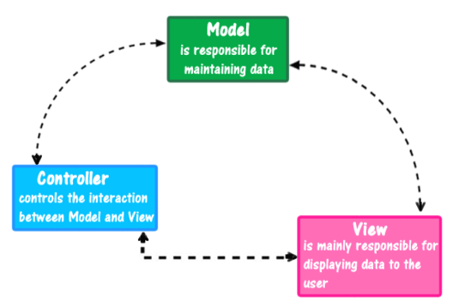

***Figure 1.5: MVC software Architecture Pattern***

The Model holds the data and logic, the View holds the visual layout and presentation, while the Controller coordinates the Model and View. Refer to Figure 1.4.1.

In summary, remember that MVC is a design pattern that we follow while we develop our applications. It is used in many other frameworks also other than AngularJS.

**1.4.3.2. MVC Pattern in AngularJS:**

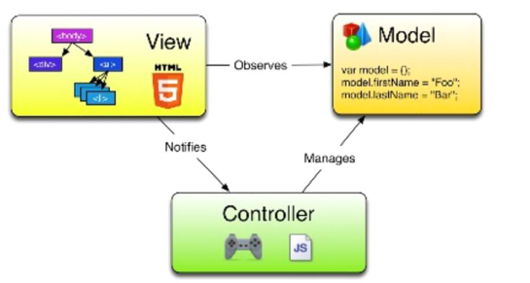

***Figure 1.6: MVC Example in AngularJS***

Model has the application data of the business. It has the data that we want to display to our users or get the user to enter through our application. So model in an AngularJS project is mostly pure data and they are represented using JSON objects. The model is only aware of itself.

View is what is visible to the users of our application. They won’t get to see the model or controller of the application they are using. As against this, generally, the view knows the model, as it has to show the data contrained in the model and calling actions (methods) on the model as and when needed.

Controller is the coding which would act as the link between the model and view. It is the responsibility of the controller to create and populate the model and give it to the view. Controller has the actual business logic and the code that fetches the data. It makes decisions about which part of the model to show to the use and how to handle validation. In other words, it has the core logic of the application.

For easy understanding, you can think of model and view as two persons standing on two sides of a bridge and the controller as the bridge which connects these two persons. Refer to Figure 1.4.3.

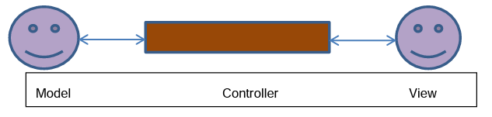

***Figure 1.7: Relationships among Components***

**1.4.3.3. MVC Architecture Benefits in AngularJS:**

We can start off with a standard HTML-based set of views and then later add a new set of views supporting a totally different format, such as a native mobile front end. According to seasoned developers, MVC-style architecture offers us a huge reduction in the effort required for the overall app development cycle.

We gain this benefit because, through MVD, we apply the principle of ‘Separation of Concerns.’ The view is in no way exclusively tied to the model, so it is far easier to handle it as a distinct component that we can exchange out for another.

MVC helps in the testing phase also. It leads to applications that are much easier to test unit wise and the total applications as a whole. The test process is continues as the application grows in complexity.

MVC is a tried and tested way to build robust applications. Once you start to see this in action, as the app development gets on, it will be very obvious to you.

# CHAPTER 2: PROBLEM DEFINITION

*This project has the following functionalities:*

## 2.1. The Home Page should be created making use of Frames with a suitable logo:

## 2.2. The look and feel of the project must be made user friendly and uniformity in the color combination must be maintained:

## 2.3. About us, Contact Us (address and map) must be added. In the Contact Us page the website of all the shops location must be given:

## 2.4. All the categories of the products like HAIR, SKIN, MAKE-UP KITS, NAIL PAINTS, NAIL ARTS, JEWELLRY, WEDDING KITS, UPCOMING PRODUCTS & so on. For each product the cost must be mentioned in the list:

## 2.5. Feedback page must be added to take the valuable feedback from the users:

## 2.6. Contact Us, About Us:

Contact page is the support. This section helps the user to find the answer for their questions as well as how to contacting us. Contact page is a pretty important site in website. Because it let everyone contact us with question or for assistance as well as given us feedback by entering their personal information will be send to us. This contact page to collect the opinions of the users, help us to improve our website for even better.

## 2.7. Use GeoLocation API to show the address or location of SIMPLON’s Beauty care center on the maps:

## 2.8. Gallery section can be included:

## 2.9. Navigation of the project must be made user friendly:

## 2.10. Customer must be allowed to place the order by selecting the product:

## 2.11. While placing the dummy order, the total cost of the order must be calculated:

# CHAPTER 3: REQUIREMENT ATTRIBUTES

## 3.1. Main Requirements:

The Main Requirements include HTML5, CSS3, Bootstrap, JQuery, AngularJS, Node JS.

## 3.2. Critical Use Case Specification:

|  |  |  |  |
| --- | --- | --- | --- |
| **USE CASE SPECIFICATION** | | | |
| **Use-case No.** | UC01 | **Use-case Version** | 1.0 |
| **Use-case Name** | *Manage cart* | | |
| **Purpose:**  A user can search for a product of his choice by entering name of product. Then a select query is used to retrieve data from the database and display the selected information.  **Input:**  The user will enter name of product in the search box.  **Output:**  The system will display the products which match the search criteria and the user can click to link to its detail page. | | | |

|  |  |  |  |
| --- | --- | --- | --- |
| **USE CASE SPECIFICATION** | | | |
| **Use-case No.** | UC02 | **Use-case Version** | 1.0 |
| **Use-case Name** | *Sign Up* | | |
| **Purpose:**  Customers can register 1 account to facilitate the purchase and payment for products as well as accumulated points promotions.  **Input:**  The user need click Sign-in button in NavBar then click Sign Up button.  **Output:**  The browser will pop up information form then user need to fill all require information to create a new account. | | | |
| **USE CASE SPECIFICATION** | | | |
| **Use-case No.** | UC03 | **Use-case Version** | 1.0 |
| **Use-case Name** | *Sign In* | | |
| **Purpose:**  Customers have account can log in.  **Input:**  The user need click Sign-in button in NavBar then click Sign In button to log in.  **Output:**  The browser will pop up log in form then user need to fill ID and password to log in. | | | |
| **USE CASE SPECIFICATION** | | | |
| **Use-case No.** | UC04 | **Use-case Version** | 1.0 |
| **Use-case Name** | *Add cart* | | |
| **Purpose:**  Customers want to buy a product, they can click Add cart button.  **Input:**  Click Add cart button to add product into shopping cart.  **Output:**  The browser will pop up small cart form to display the product have been added. | | | |
| **USE CASE SPECIFICATION** | | | |
| **Use-case No.** | UC05 | **Use-case Version** | 1.0 |
| **Use-case Name** | *Check out* | | |
| **Purpose:**  After adding some products, if customer want to check again what they have bought they can click checkout button to check and they can delete or add more quantity to shopping cart.  **Input:**  Hover Cart Icon, then click Check Out Button.  **Output:**  The browser display a page with shopping cart inside. | | | |
| **USE CASE SPECIFICATION** | | | |
| **Use-case No.** | UC06 | **Use-case Version** | 1.0 |
| **Use-case Name** | *Payment* | | |
| **Purpose:**  Paying for bought products.  **Input:**  Click payment to change to Payment Portal  **Output:**  The browser will pop up Payment Portal form then user need to fill all require information to complete payment. | | | |

## 3.3. Use case Diagram:

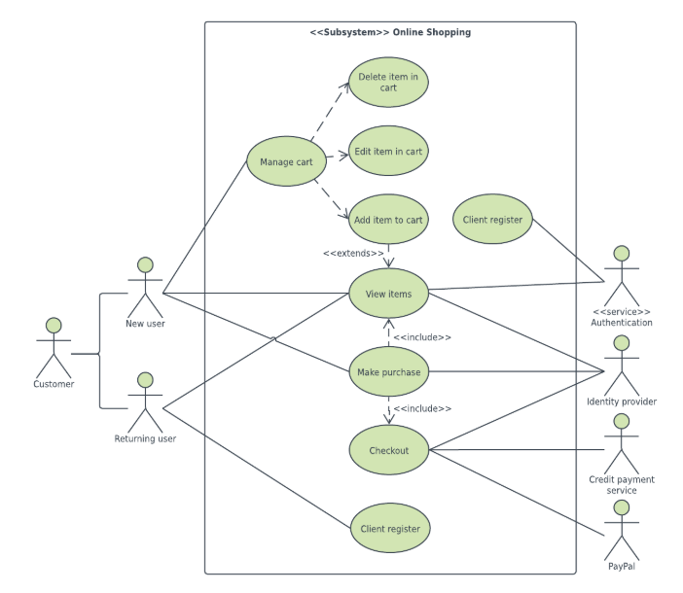

Figure .: User use case diagram

***Fig 3.1: User use case diagram***

# CHAPTER 4: DESIGN PROTOTYPE

## 4.1. Website mapping:



***Figure 4.1: Website mapping***

## 4.2. Home page prototype:



***Figure 4.2: Homepage prototype***

## 4.3. Products page prototype:



***Figure 4.3: Products page prototype***

## 4.4. Product detail page prototype:



***Figure 4.4: Product detail page prototype***

## 4.5. Contact us page prototype:



***Figure 4.5: Contact us page prototype***

## 4.6. About us page prototype:



***Figure 4.6: About us page prototype***

# CHAPTER 5: TECHNICAL

The technique used to build the Website:

* HTML5 & CSS3.
* JQuery.
* JavaScript.
* Bootstrap.
* AngularJS
* Node JS

## 5.1. Bootstrap framework:

We are using version 3.3.7



***Figure 5.1: Link bootstrap.min.js***

## 5.2. AngularJS framework:

We are using version 1.7.2



***Figure 5.2: Link angular.js***

## 5.3. Node JS:

We are using version 8.12.0 LTS

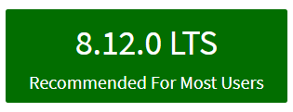

***Figure 5.3: Node JS version***

# CHAPTER 6: THE PAGES BASIC OF WEBSITE:

## 6.1. Home page screenshot:

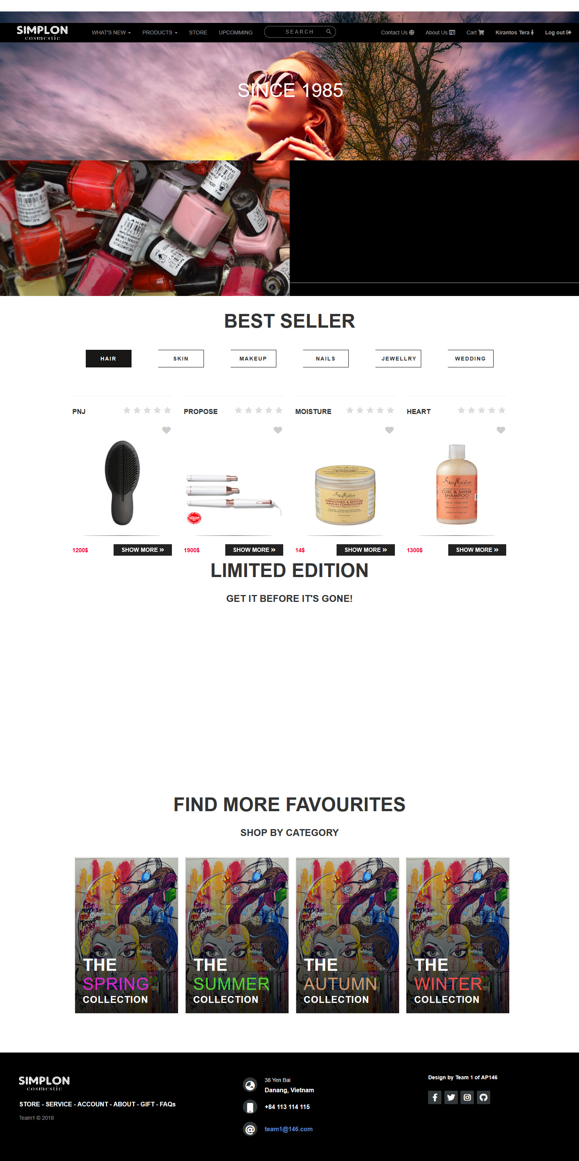

***Figure 6.1: Homepage***

## 6.2. Products page screenshot:

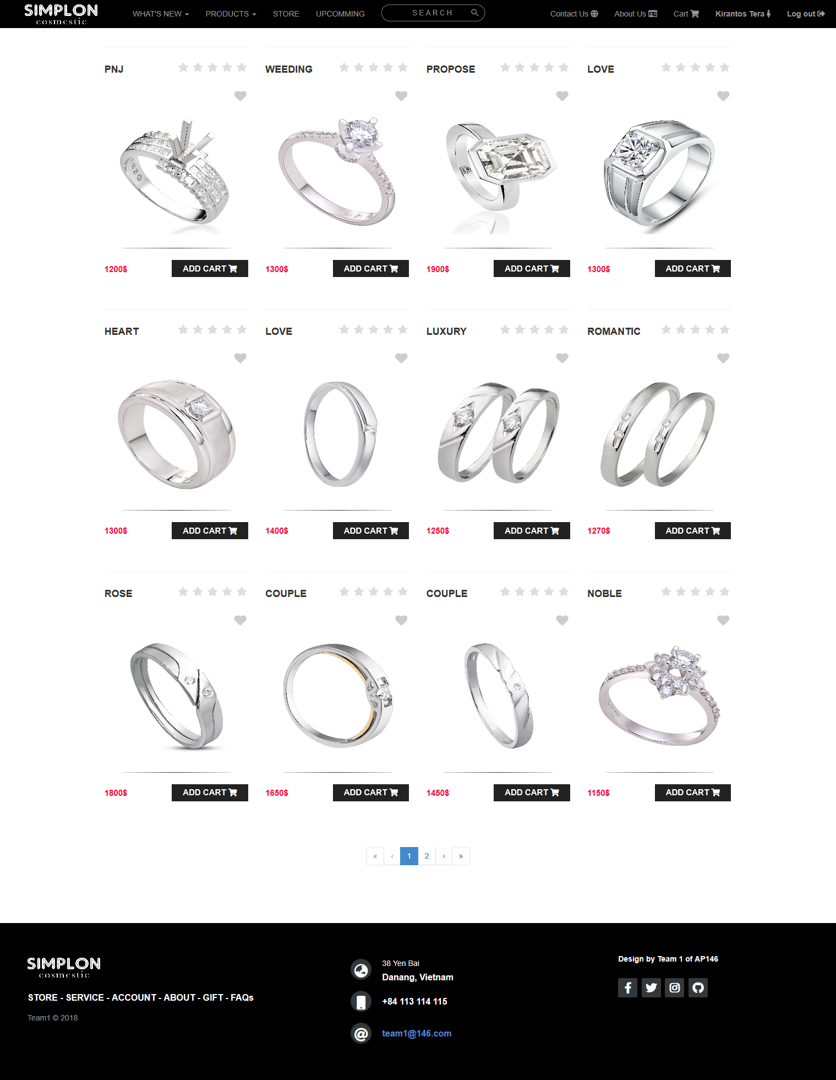

***Figure 6.2: Products page***

## 6.3. Product detail page screenshot:

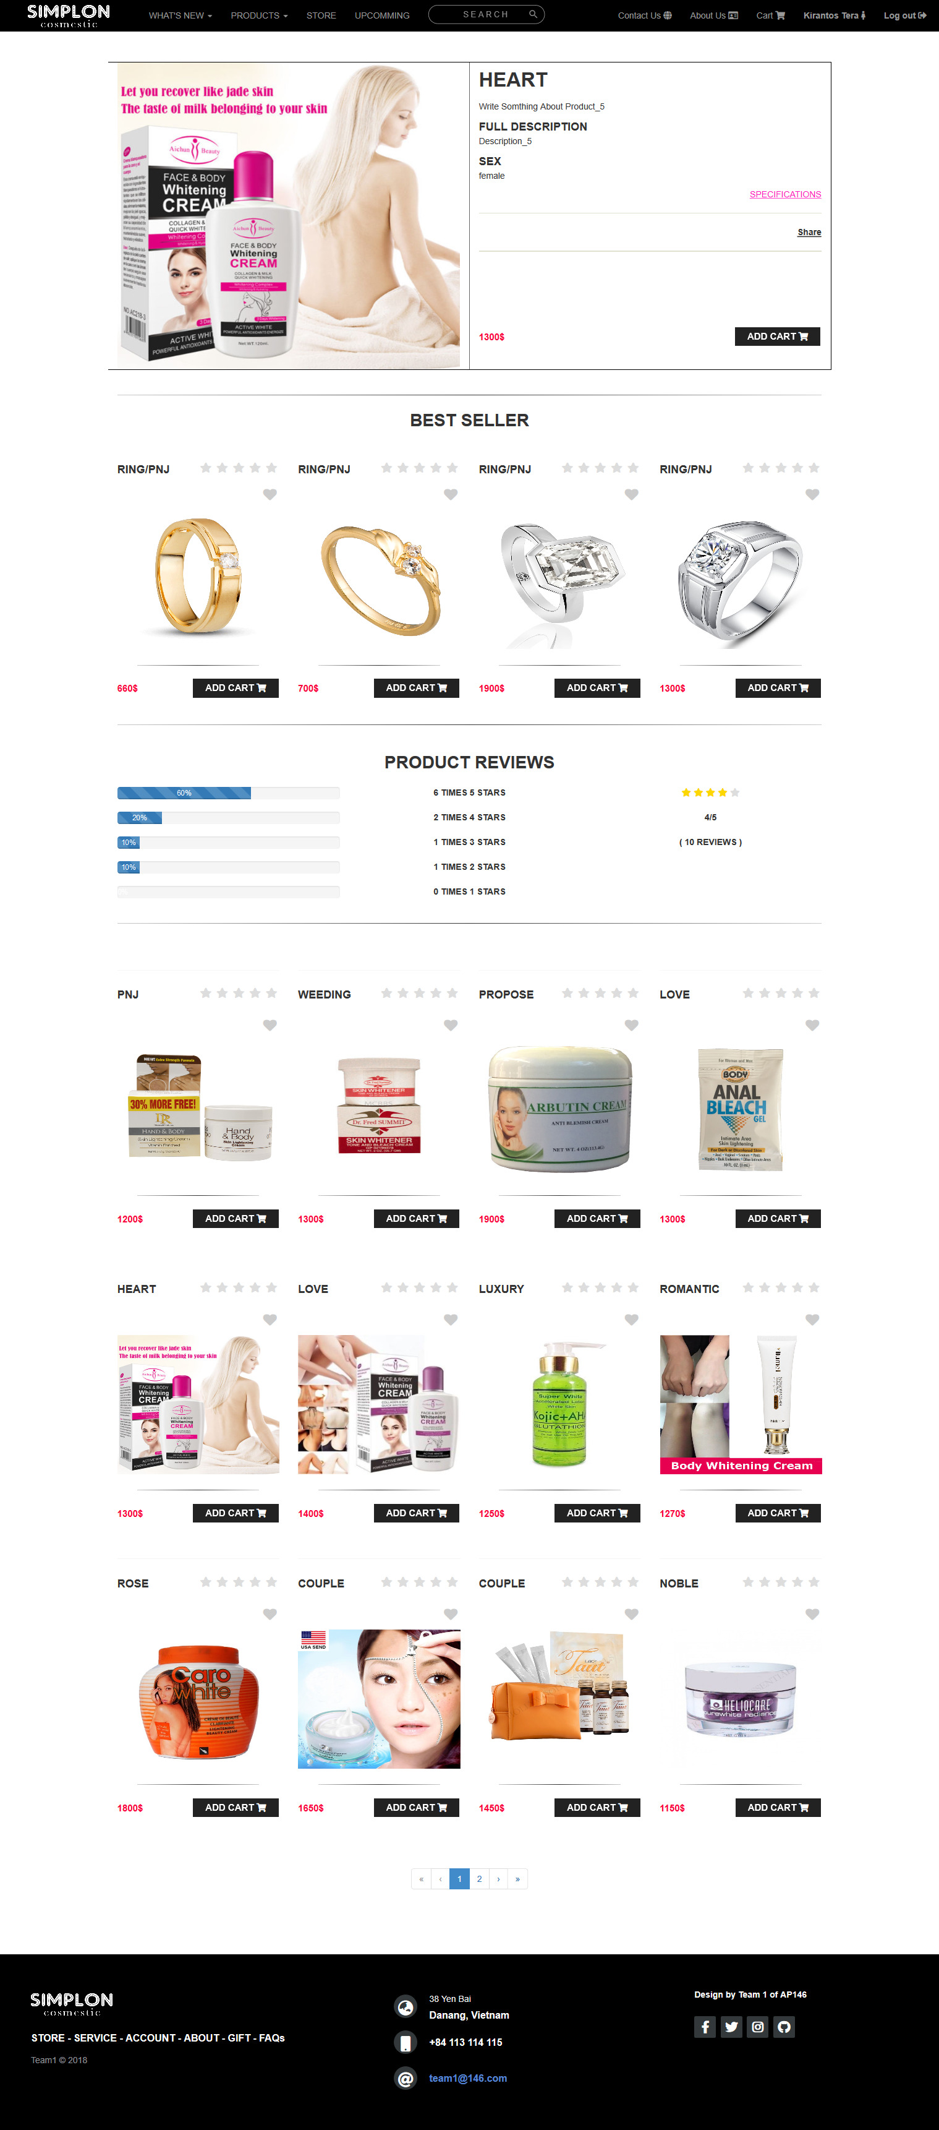

***Figure 6.3: Product detail page***

## 6.4. Checkout page screenshot:

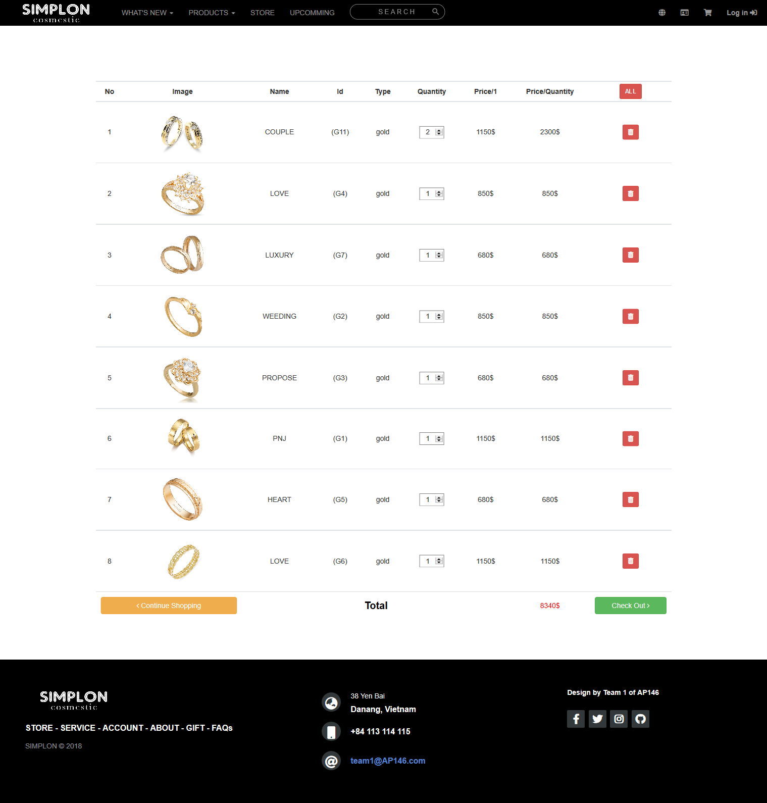

***Figure 6.4: Checkout page***

## 6.5. Contact us page screenshot:

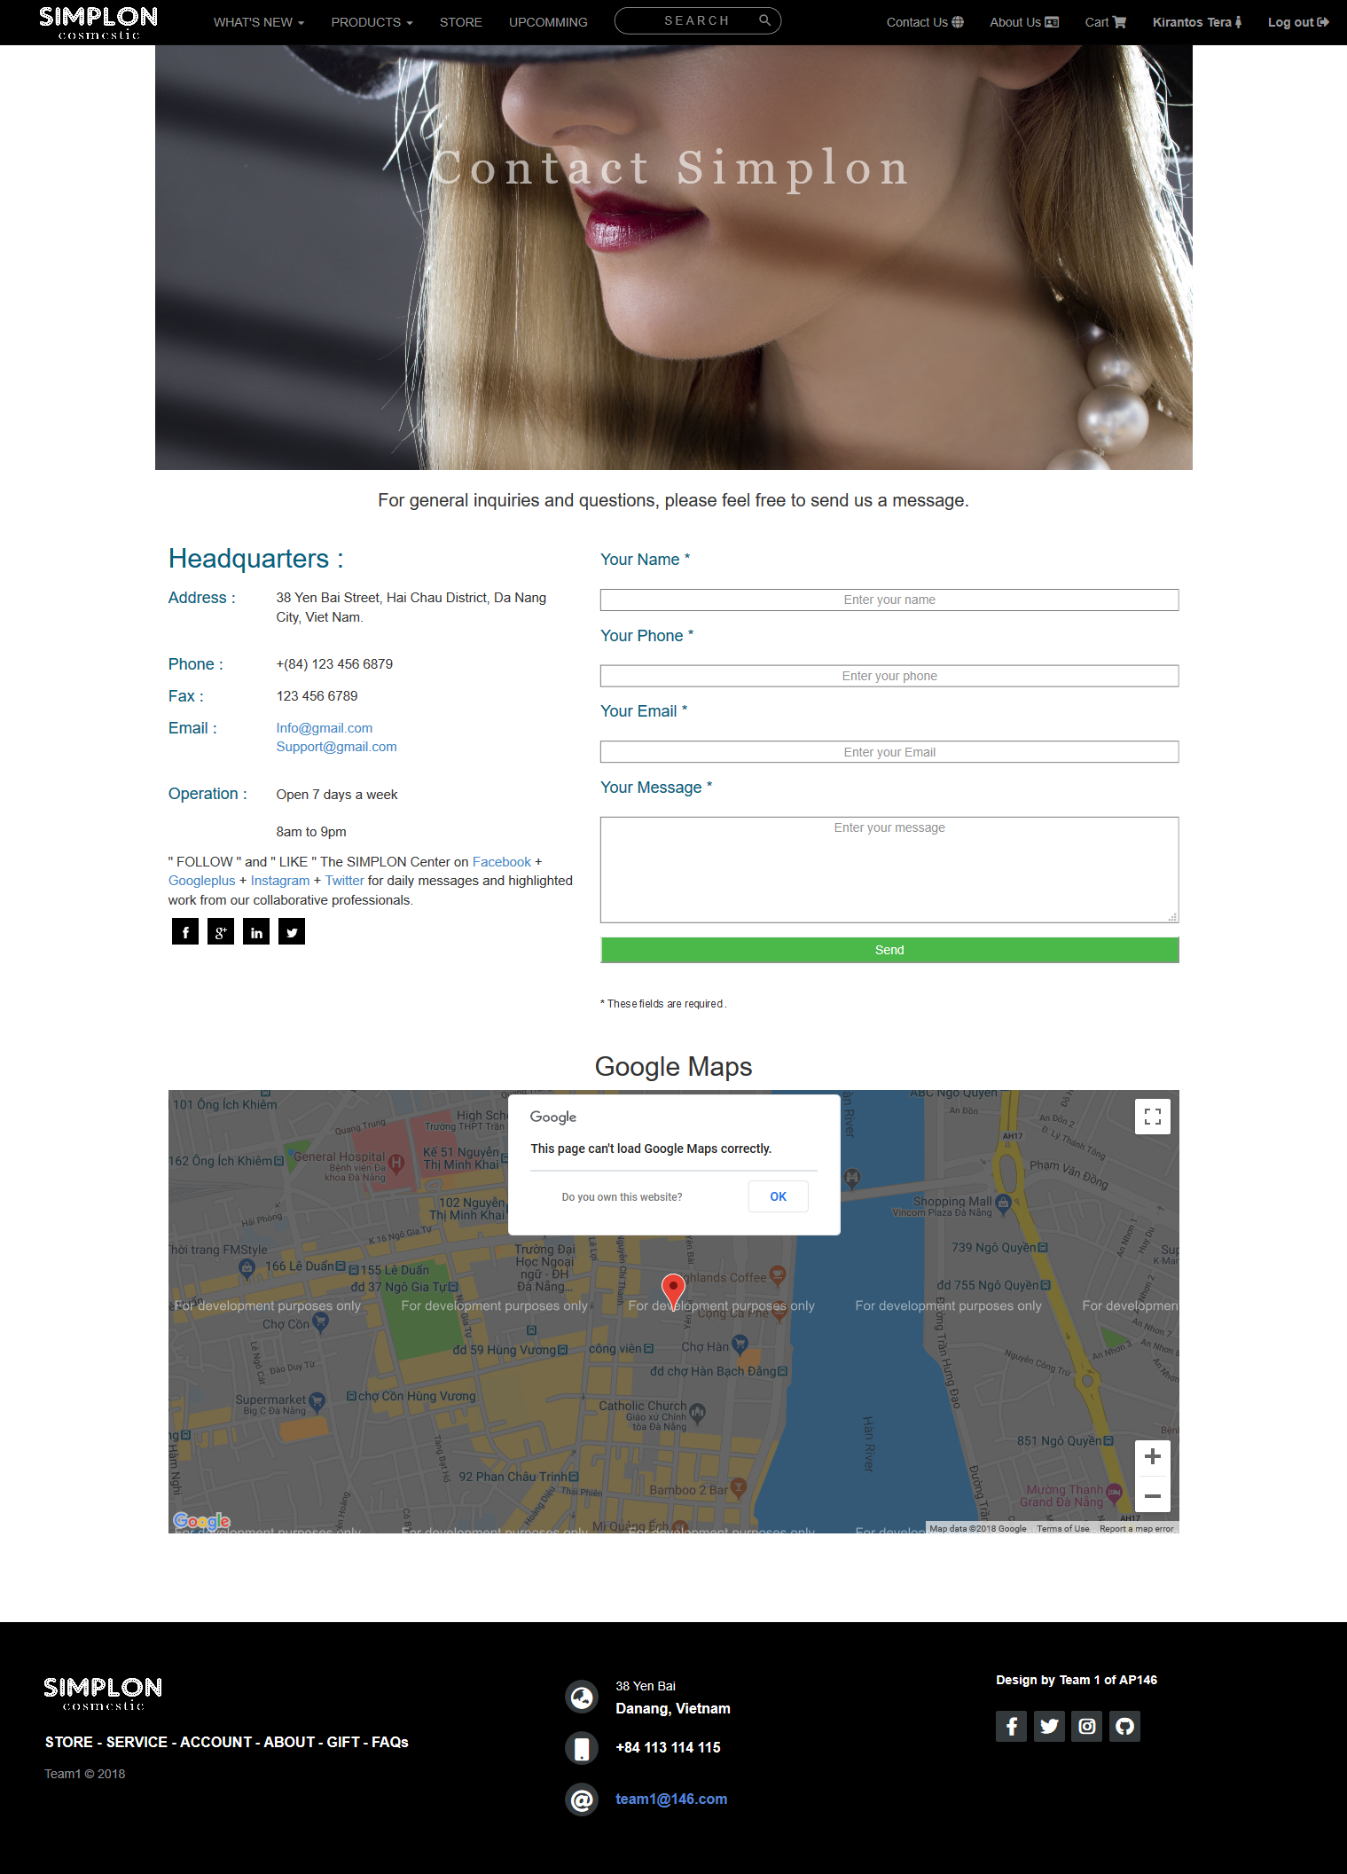

***Figure 6.5: Contact us page***

## 6.6. About us page screenshot:

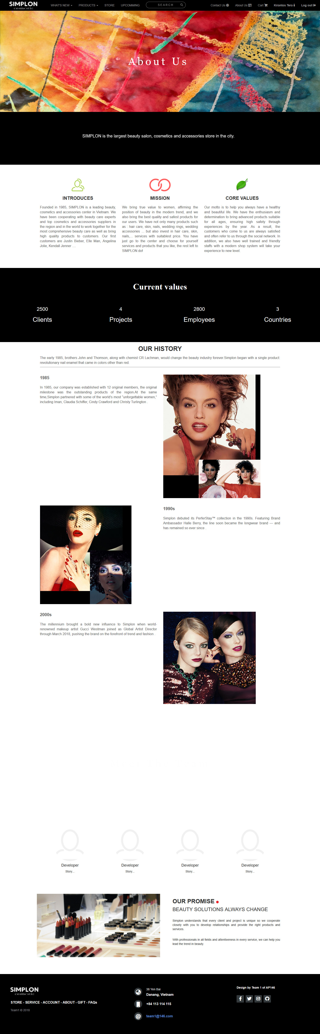

***Figure 6.6: About us page***

# CHAPTER 7: USER GUIDE

## 7.1. Instructrion:

We are using Node JS for reading and saving data so need install Node JS first.

## 7.2. Running step by step:

### 7.2.1. Download project:

We are using GIT and GitHub for remote repository. There 2 ways you can download this project:

### 7.2.1.1. Without GIT:

+ Go to <https://github.com/>

+ Enter: beautycare at Search Box (Search Github)

+ Then select:

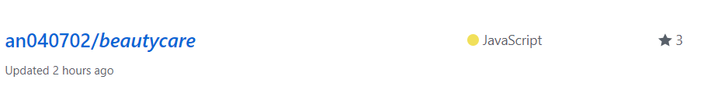

+ Click “**Clone or Download**” button then click “**Download ZIP**”:

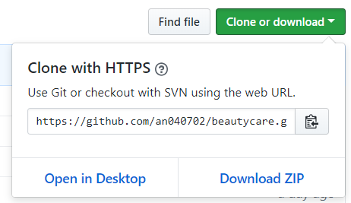

### 7.2.1.2. Using GIT:

Open cmd.exe or Git Bash then enter this command:

***Git clone*** [***https://github.com/an040702/beautycare.git***](https://github.com/an040702/beautycare.git)

### 7.2.2. Running server:

Go to ***beautycare*** folder, then use cmd.exe, and enter this command:

***Node server.js***

The path should look like this firgure:

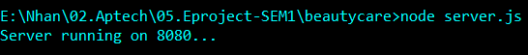

### 7.2.3. Running web pages:

Open browser, we use **Chrome** for example. At url input enter this:

***Localhost:8080***

Website will display like this:

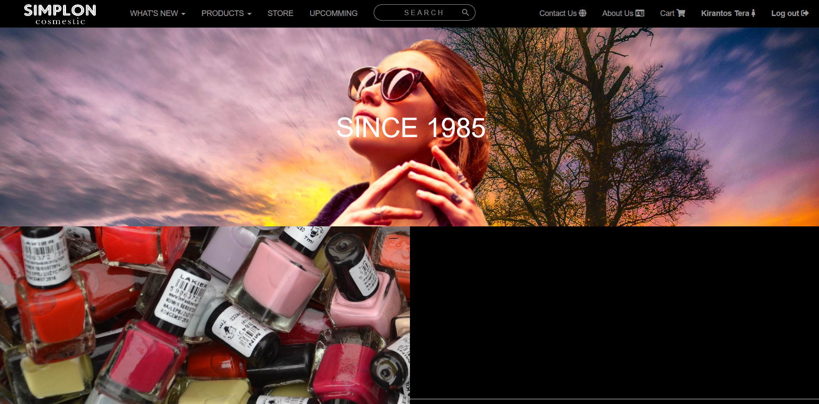

Then you can view what ever you want via navigation bar.

7.3. Developer’s guide:

Our project on GitHub:

